Index
Content | Page No
CHAPTER-1
INTRODUCTION:
  - EXISTING SYSTEM.
  - NEED OF PROPOSED SYSTEM
  - PROPOSED MODULES.
  - SOFTWARE PROCESS MODEL.
  - FEASIBILITY STUDY.
  - HARDWARE AND SOFTWARE REQUIREMENT
2. CHAPTER-2
ANALYSIS:
2.1. STRUCTURAL ANALYSIS
2.1.1.REQUIREMENT
2.1.1.1.FUNCTIONAL REQUIREMENT
1.1.2.NONFUNCTIONAL REQUIREMENT
2.1.2. DATA DICTIONARY
2.1.3.ER DAIGRAM
2.1.4. DATA FLOW DIAGRAM
2.2. OBJECT ORIENTED ANALYSIS
2.2.1. USE CASE DIAGRAM
2.2.2. CLASSDIAGRAM
2.2.3. ACTIVITY DIAGRAM
CHAPTER-3
DESIGN
3.1. STRUCTURE
3.1.2. GUI DESIGN
CHAPTER-4
IMPLEMENTATION & TESTING
4.1. IMPLEMENTATION
4.2 TESTING
CHAPTER-5
RESULTS
5.1. PROJECT OUTCOMES
5.2. PROJECT SNAPS
CHAPTER-6
FUTURE ENHANCEMENT AND CONCLUSION
6.1. FUTURE ENHANCEMENT
6.2. CONCLUSION
CHAPTER-7
REFRENCES & BIBLIOGRAPHY

STUDENT MANAGEMENT SYSTEM

The Government identified the quality health services and the efficiency of government managed hospitals as key contributors for building trust and confidence for the general hospitals in the heart of the citizen of the state.
Student Management System (SMS) tracks all the details of a student from the day one to the end of his course which can be used for all reporting purpose, tracking enrolment, progress in the course, completed semesters years, final exam results and all these will be available for future references too.
Our project will have the databases of courses offered by the college under all levels of graduation or main streams

To overcome the complexity of this environment and to manage its resources with optimal efficiency, Institute management need to have robust and integrated Student Management System for their day to day operation. “Student Management System”is unparallel and comprehensive Student Management System that covers each and every entity of Institute like students, faculties and management.

ACKNOWLEDGEMENT

I would like to extend our heartiest thanks with a deep sense of gratitude and respect to all those who provides me immense help and guidance during my training period.

I would like to thank my Project Leader ………… for providing a vision about the system. I have been greatly benefited from their regular critical reviews and inspiration throughout my work.

I would also like to thank my Module Leader ……….. for his unfailing cooperation and sparing his valuable time to assist me in my work.

I would like to express my sincere thanks to our Head of Department Dr. K. H. Wandra and my internal guide .............. and ............, who gave me an opportunity to undertake such a great challenging and innovative work. I am grateful to them for their guidance, encouragement, understanding and insightful support in the development process.
I am also thankful to entire staff of TCS for their constant encouragement, suggestions and moral support throughout the duration of my project.

Last but not the least I would like to mention here that I am greatly indebted to each and everybody who has been associated with my project at any stage but whose name does not find a place in this acknowledgement.

.

With sincere regards,

CANDIDATE’S DECLARATION

I declare that final semester report entitled “ STUDENT MANAGEMENT SYSTEM – AN EXTENSION TO HMIS ” is my own work conducted under the supervision of the external guide Mr. .......................from ......................................
I further declare that to the best of my knowledge the report for B.E. final semester does not contain part of the work which has been submitted for the award of B.E. Degree either in this or any other university without proper citation
Also I declare that following student also worked in this project:
- ……………………
.............................................

Candidate Signature:

Submitted To:

College name and address

Mono of college

CERTIFICATE

T O W H O M S O E V E R I T M A Y C O N C E R N
This is to certify that Mr. RAJA BISWAS of B. E. Semester VIII (Information Technology) has completed his project work titled “ STUDENT MANAGEMENT SYSTEM – AN EXTENSION TO HMIS ” satisfactorily in partial fulfillment of requirement of Bachelor of Engineering degree course, Saurashtra University, Rajkot, in the year 2010-2011.
Internal Project Guide:
Mr. Rahul Joshi Dr. K. H. Wandra
(Analysis Guide) (Vice-Principal & HOD CE / IT Dept)

Mr. Devendra Thakor
(Technical Guide)

External Project Guide:
Mr. Dhaval Patel
(Business Associate, TCS Gandhinagar)

Chapter 1

INTRODUCTION
________________________________________________

  - EXISTING SYSTEM
Many of the school are not having proper software so that they can manage all the student information and they can not analysis the student record also for the betterment of the student. All the school those are using manual record keeping system they have to find every thing from the register and they have to maintain the record manually which is very old and time consuming technique.
The current system for the Student Management System deals with maintaining a physical contact with the academy management dept. for filling all the details and the documentation work. The management doesn’t needs to visit the academy management dept. and collect the assignment and submitting his/her documents directly.
According to the current system, the management has to fill in the forms manually, go to the account management dept., and submit him the form. The applicant needs to visit the academy portal now and then in order to get his work accomplished. The admin also has to manage all the users. He needs to maintain records of all the users, their activity status, submission methods and installation details on paper. The Manual process is more error prone and also slow. Moreover Students in the academy can interface his/her work area only. But if an online application is available then they can communicate whole system. Thus a simulation of this entire process can be a boon to the applicants as well as the admin.

- The present system has certain major disadvantages. A few to be listed can be excessive paperwork, time consuming process flow, laborious work environment for employees, difficulty to access historical data and all these problems lead to inefficient working of government sector causing dissatisfaction in the general public.
- Apart from the above stated problems there is lack of transparency in the existing system. This being one of the major drawbacks in the system needs special attention.
- The problem stated above have certain deep rooted problems like time consuming process flow for which the government may need to change the structure of the process flow in certain cases so that the system output can become faster.
- The following listed are the problems or weaknesses of the current system:

- So much time consume in preparing registers which is having replicated data
- It is difficult to prepare report for decision making.
- Attendance related module is not there.

  - NEED OF PROPOSED SYSTEM

Our Student Management System is very helpful to student and teacher also because all the details can be manage by simple click and from any where and any time because we are going to make online student management system which provides all the information about the student and course including teachers and students.
Admin session is also there who will manage the both student as well as the teacher profile and course selection also.

  - PROPOSED MODULES.
A Student Management System (SMS) is a System that manages the records of student regarding admission and examination part.
A Student Management System (SMS) is designed to help collages for management of dental student. Extensive information is available at your fingertips through this System. Viewing student data, managing admission, course related information, course management, profile managing by admin, teacher allotment for particular subject etc. are made simple and easy. There are custom search capabilities to aid in finding student information and working on student records. This can make the system easier to navigate and to use maximizing the effectiveness of time and other resources. SMS allows the keeping of personnel data in a form that can be easily accessed and analyzed in a consistent way.

The SMS module is a component covering many other student aspects from application to retirement. The system records basic personal information, admission information, education information regarding student. Leading edge systems provide the ability to "read" applications and enter relevant data to applicable database fields, notify student and provide result.

In SMS, every user has a Login ID and Password. Also all the users have different permission rights to access the applications. These rights are Dynamic and can be changed.

There are three main roles in the system. Admin, accountant and operator. Admin has complete access to the whole system, while accountant is only concerned with payment of fees for the admission of the student. Operator is the role that is responsible for the use of the system.

Now when the user with the particular role Logs on he can see only those pages which are allowed to them.

  - SOFTWARE PROCESS MODEL

The project is about to handle all the information of the student regarding admission and examination. Also it manages resources which were managed and handled by manpower previously. The main purpose of the project is to integrate distinct sections of the organization into consistent manner so that complex functions can be handled smoothly by any technical or non-technical persons. The main purpose of the Admin Module is to introduce new things and configure important aspects. For e.g. only admin is authorized to Add Course, Edit Course, Add Any new student, Edit His Own Profile, Sechedule Course assign to him self . So the master screens for all these are visible to only admin role. This is done by the Admin Module. It also can create the users and Physical and Logical Locations. Thus the main purpose of the Admin Module is to managing the dynamic working of the system.

  - FEASIBILITY STUDY

The aim of the feasibility study activity is to determine whether it would be financially and technically feasible to develop the system or not. A feasibility study is carried out from following different aspects:

Operational Feasibility:

The system has been developed for any user who wants to use this system. We have given a demo of our project and the users found the system friendly and easy to use. The interoperability with the existing system is also checked after uploading the website. So they may face certain problems in using the user interface. So keeping this consideration in mind we have provided field for each and every field on the forms. The administrator also may be non-technical, so the user interface is designed in such a way that it gets comfortable for the non-technical person to operate easily.

Technical Feasibility:

It determines if the system can be implemented using the current technology. This system has been developed using PHP as front end and MY SQL Server as backend. Though the Internet technology was new to us it was not so difficult for us to learn it. This was also new to us but it didn’t take much effort and time to get used to it. We had earlier worked with Access and not SQL Server 2005 but getting familiar with it was also easy.

Economical Feasibility:

The company being a well-to-do company didn’t have any problem in buying any software that was required in developing the application. The software’s we used were readily available. So as such we didn’t face any economical constrains.

Implementation Feasibility:

This project can easily be made available online without much consideration of the hardware and software. The only required thing at the applicant’s side is the Internet connection and a web browser, which are a no difficult issue these days. A database server and application server are required to set up at the admin side. After setting up the project online, even the administrator can access the system from anywhere.

  - HARDWARE AND SOFTWARE REQUIREMENT
- Hardware Requirement

Client Configuration
Pentium IV, 750 MHz, 20GB HDD
Operating System: Windows XP/2000
RAM: 256 MB minimum
400MB Minimum Free Space on Drive
Microsoft Office
Server Configuration
2 Servers, each with following configuration
2 CPU
Operating System: Win XP
RAM: 512MB Minimum
40GB Minimum Free Space on Drive
750MHz
One Server with mySql Application Server
Other Server with mySql Database Server

- Software Requirement

Development technologies | PHP
Development tools | PHP
Application server | IIS 7.5
Database | MYSQL
Operating system | Windows XP Profession Edition, Windows Vista Enterprise Edition
Web browser | Internet Explorer 6.0 and above

Chapter 2

ANALYSIS ________________________________________________

2.1. STRUCTURAL ANALYSIS

The basic idea behind iterative enhancement is to develop a software system incrementally, allowing the developer to take advantage of what was being learned during the development of earlier, incremental, deliverable versions of the system. Learning comes from both the development and use of the system, where possible. Key steps in the process were to start with a simple implementation of a subset of the software requirements and iteratively enhance the evolving sequence of versions until the full system is implemented.

At each iteration, the procedure itself consists of the Initialization step, the Iteration step, and the Project Control List. The initialization step creates a base version of the system. The goal for this initial implementation is to create a product to which the user can react. It should offer a sampling of the key aspects of the problem and provide a solution that is simple enough to understand and implement easily. To guide the iteration process, a project control list is created that contains a record of all tasks that need to be performed. It includes such items as new features to be implemented and areas of redesign of the existing solution. The control list is constantly being revised as a result of the analysis phase.

The iteration involves the redesign and implementation of a task from project control list, and the analysis of the current version of the system. The goal for the design and implementation of any iteration is to be simple, straightforward, and modular, supporting redesign at that stage or as a task added to the project control list. The code can, in some cases, represent the major source of documentation of the system. The analysis of an iteration is based upon user feedback, and the program analysis facilities available. It involves analysis of the structure, modularity, usability, reliability, efficiency, and achievement of goals. The project control list is modified in light of the analysis results.

2.1.1.REQUIREMENT
2.1.1.1. FUNCTIONAL REQUIREMENT

Phases | Time Period | No. of days | Deliverables of the phase
Feasibility Analysis | 17th Jan. – 22th Jan. | 6 | Feasibility Report document
Requirement Gathering | 23th Jan. – 01st Feb. | 10 | System Requirement Study
Analysis | 02nd Feb. – 10th Feb. | 09 | System Requirement Study
Design | 11th Feb. – 05th Mar. | 23 | Design document
Implement Coding | 06th Mar. – 9th April. | 35 | Implementation of system
Testing | 10th April. – 13th April. | 4 | Testing Document
Final Evaluation | 20th April. | 1 | Report Submit

2.1.1.2. NON FUNCTIONAL REQUIREMENT

Role | Responsibility |  | Team/Member
Project Guide | Defining scope |  | Mr. Dhaval Patel
Project Guide | Providing required resources |  | Mr. Dhaval Patel
Project Guide | Project planning, tracking and monitoring. |  | Mr. Dhaval Patel
Project Guide | Analysis and Effort Estimation. |  | Mr. Dhaval Patel
Project Guide | Coordination between project teams. |  | Mr. Dhaval Patel
Project Developer | Designing & Documentation | Self
Project Developer | Execution project as per defined schedule.
Project Developer | Reporting to PL
Project Developer | Testing & QA/QC
Project Developer | Software development as per the design and Documentation

2.1.2. DATA DICTIONARY

A data dictionary is a catalog --a repository-- of the elements in a system. It includes list of all the elements composing the data flowing through a system. The major elements are data flows, data stores, and processes. It store definitions and detailed descriptions of the data used in an organization’s information system
It is important because –

- To manage the detail in large systems
- To communicate a common meaning for all system elements
- To document the feature of the system
- To facilitate analysis of the details in order to evaluate characteristics and determine where system changes should be made
- To locate error and omissions in the system

List of Data Tables:
            - Student Master
            - Course Master
            - Room Master
            - Admin Master
            - Teacher Master
            - Room Details
            - Faculty Designation
            - Faculty Details
            - Student Admission Details
            - Student Education Details
            - Student Personal Details
            - Subject Exam Type Details
            - Subject Master

Table 2.1 Table Structure of Attendance

Field | Type | Null | Key | Description
Attendance_id | int(11) | NO | PRI | primay key
attendance_student_schedule_id | int(11) | NO
attendance_date_id | Int(11) | NO
attendance_check | Char(1)

Table 2.2 Table Structure of Course Master

Field | Type | Null | Key | Description
course_id | int(11) | NO | PRI | primary key
course_name | varchar(100) | NO |  | Category name (e.g. SC,OBC)
course_desc | varchar(255) |  |  | Description to the category
course_active | tinyint(1)
course_fee | int(11)

Table 2.3 Table Structure of crc_date
Field | Type | Null | Key | Description
date_id | int(11) | NO | PRI | primary key
date_day | char(2) | NO |  | Course name
date_month | char(2) | NO |  | Duration of course in sem
date_year | varchar(4)

Table 2.4 Table Structure of crc_feedback

Field | Type | Null | Key | Desciption
feedback_id | int(11) | NO | FK | Exam Master
feedback_profile_id` | int(11) | NO | FK | Subject Exam Type Detail
feedback_schedule_id | int(11) | NO |  | Date of Exam
feedback_date | timestamp | NO |  | Time of Exam
feedback_active | tinyint(1) | NO

Table 2.5 Table Structure of crc_feedback_answer

Field | Type | Null | Key | Desciption
feedback_answers_id | Int(11) | NO | PRI | Primary Key
feedback_answers_feedback_id | Int(11) | NO | FK
feedback_answers_questions_id | Int(11) | NO | FK
feedback_answers_answer | Text | NO
feedback_answers_active | Tinyint(4) | NO
feedback_answers_comments | Text | NO

Table 2.6 Table Structure of crc_feedback_questions

Field | Type | Null | Key | Description
feedback_questions_id | Int(11) | NO | PRI | Primary key
feedback_questions_question | Text | NO
feedback_questions_active | Tinyint(1) | NO
feedback_questions_category | Varchar(100) | NO
feedback_questions_sequence | Int(11) | NO

Table 2.7 Table Structure of crc_profiles

Field | Type | Null | Key
profile_id | Int(11) | NO | PRI
profile_uid | Varchar(100) | NO
profile_pwd | Varchar(40) | NO
profile_firstname | Varchar(100) | NO
profile_lastname | Varchar(100) | NO
profile_email | Varchar(100) | NO
profile_dob | Date | NO
profile_gender | Varchar(6) | NO
profile_employed | Tinyint(1) | NO
profile_employed_title | Varchar(100) | NO
profile_employed_company | Varchar(100) | NO
profile_address_one | Varchar(100) | NO
rofile_address_two | Varchar(100) | NO
profile_city | Varchar(100) | NO
profile_province_state | Varchar(100) | NO
profile_postal_code | Varchar(100) | NO
profile_country | Varchar(100) | NO
profile_phone_land | Varchar(14) | NO
profile_phone_cell | Varchar(14) | NO
profile_phone_fax | Varchar(14) | NO
profile_role_id | Int(11) | NO
profile_active | Tinyint(1) | NO
profile_rdn | Varchar(100) | NO
profile_date | timestamp | NO

2.1.3. ER DAIGRAM

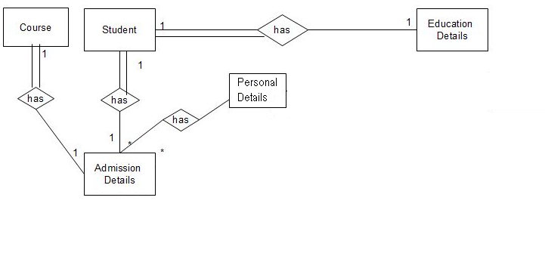

2.1.4. DATA FLOW DIAGRAM

    - Context Diagram
The context diagram is the most abstract data flow representation of a system. It represents the entire system as a single bubble and. The various external entities with which the system interacts and the data flows occurring between the system and the external entities are also represented. The name context diagram is well justified because it represents the context in which the system is to exist i.e. the external entities (users) that would interact with the system and specific data items they would be receiving from the system.
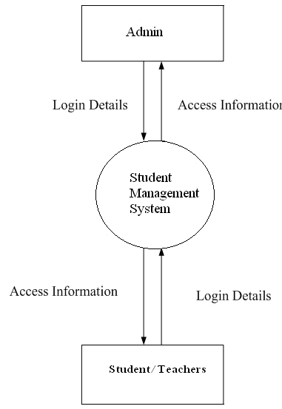
Fig 2.1.4. Data Flow Diagram of Student Management System

2.2. OBJECT ORIENTED ANALYSIS

2.2.1. USE CASE DIAGRAM

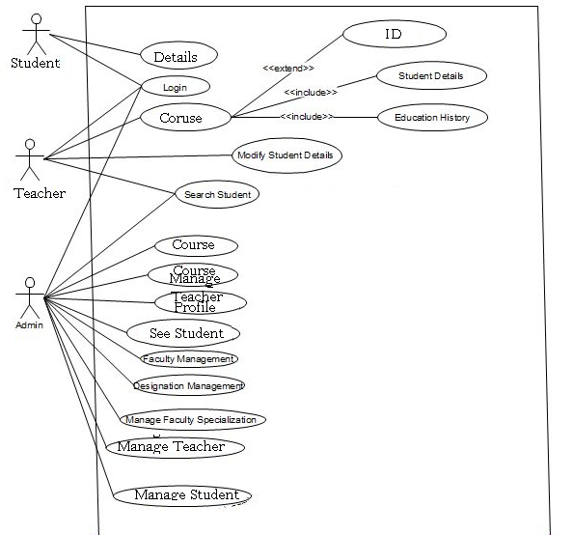

2.2.2. DATABASE CLASS DIAGRAM

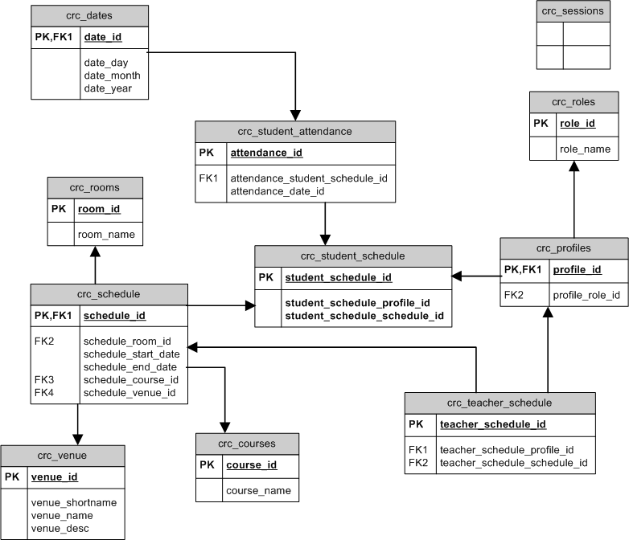

2.2.3. ACTIVITY DIAGRAM

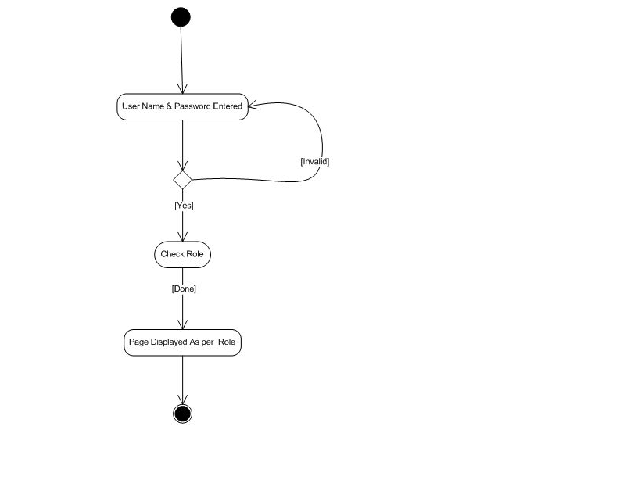

Chapter 3

DESIGN ________________________________________________

3.1. STRUCTURE
3.1.1 ARCHITECTURE DESIGN

Administrator:

The administrator has all the rights to access the system. He is the one who has all rights to view the applicant details, modify those details, The administrator also keeps a track of the file status of the applicants.

User :
Applicant is the one who wish to visit SMS. The applicant can fill in his own details and register himself for membership to use portal services. The applicant has rights to view and modify his own details, generate its candidature of containing his own details in academic web part. The applicant also rights to create groups, modify groups, invite member, modify member, join group, slam book requests, etc. In sort, the applicant can access the application like a moderator of his/her group.

Faculty/Teacher :
He can view Student Details submitted by Admin filled student which is applying for his/her status.
Admin:
The Admin is Manages the student and teacher profile and he can add, remove and modify any data related to student and teachers.

3.1.2. GUI DESIGN

Login Window

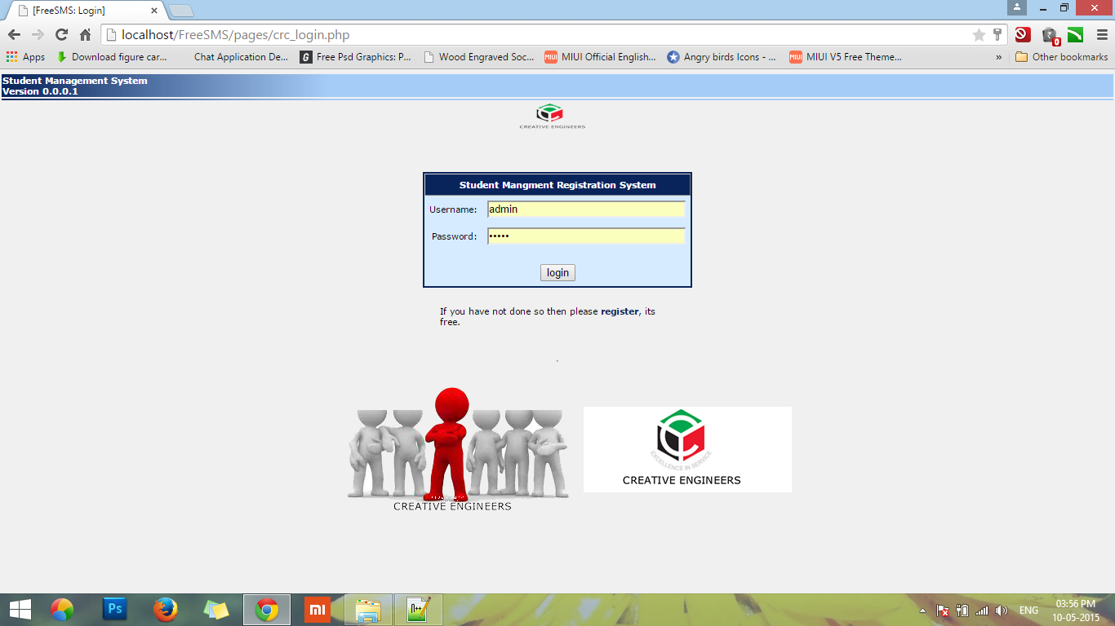

This is login windows which can be used by student, teacher and admin also.

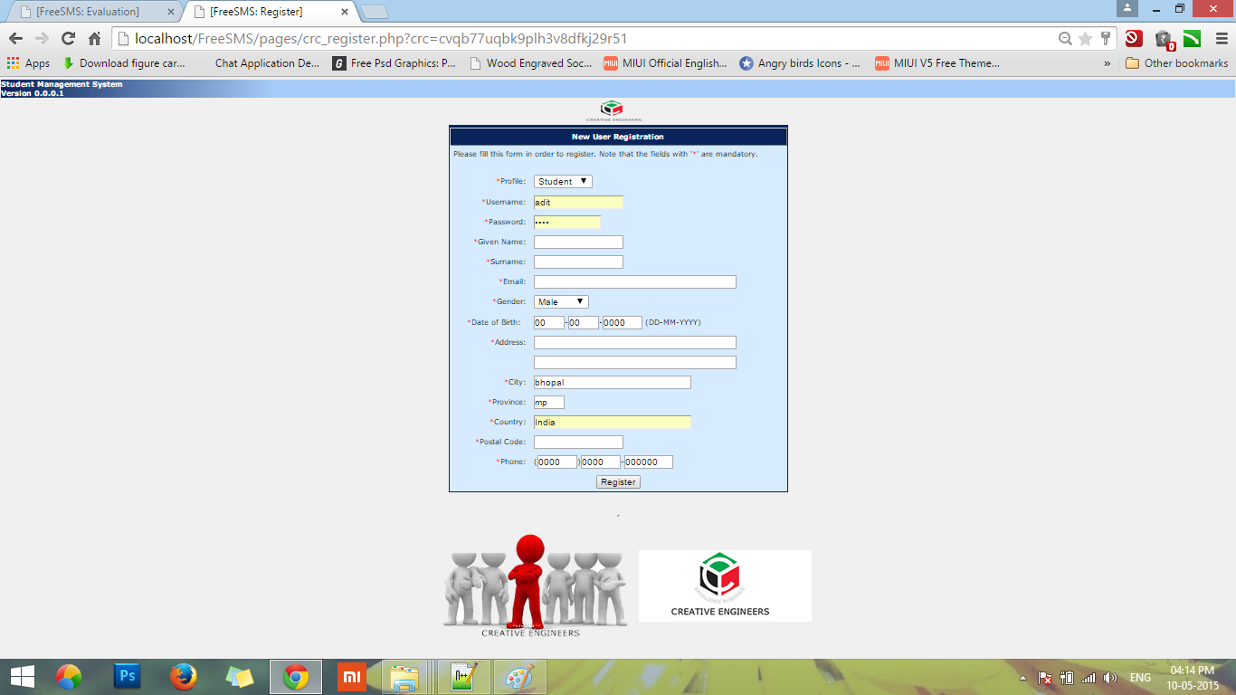
This is Registration Form For Teacher and Student
Student need to fill all the information and all these information is visible to Teacher As well as Admin admin also can alter students data or details

Admin Panel
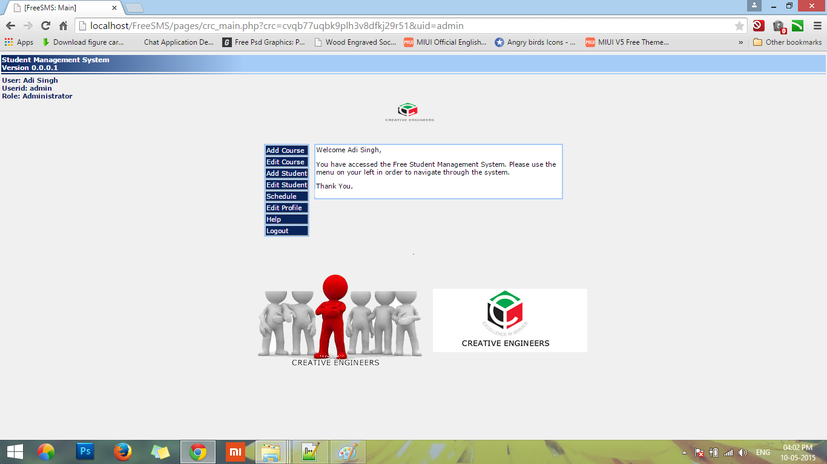

This is control Panel of Admin or This is Admin Profile Admin Can Do
- Add Course
- Edit Course
- Add Any new student
- Edit His Own Profile
- Sechedule Course assign to him self also
- Help (Common to all profile fo any kind of help with default message and admin contact)
- Logout (By clicking on profile is logged out and session end)

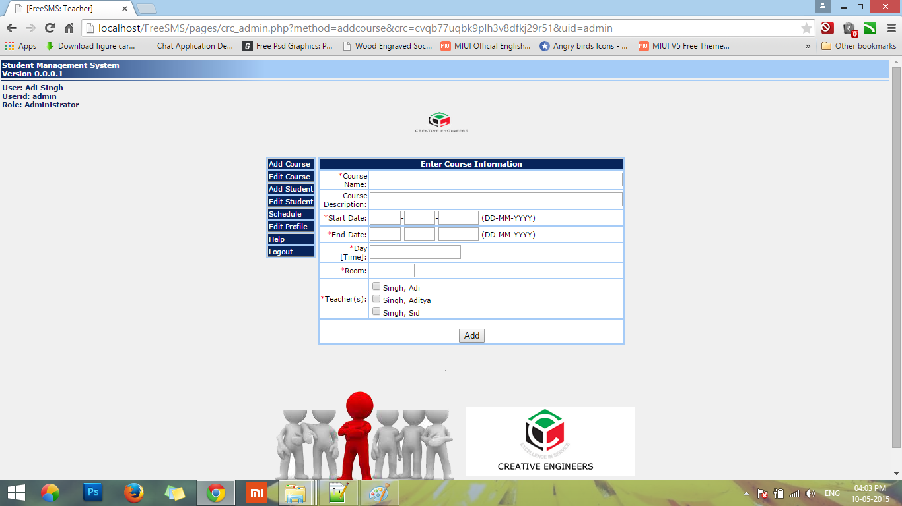

- Admin is adding Course form this Screen
- He should know all the information about course
- From here admin assign Subject to available teachers
- Admin will Add
Course name
Course description
Start date and End Date of subject session
Room no. where the classes will be held
And checkbox the teachers who is going to take this subject

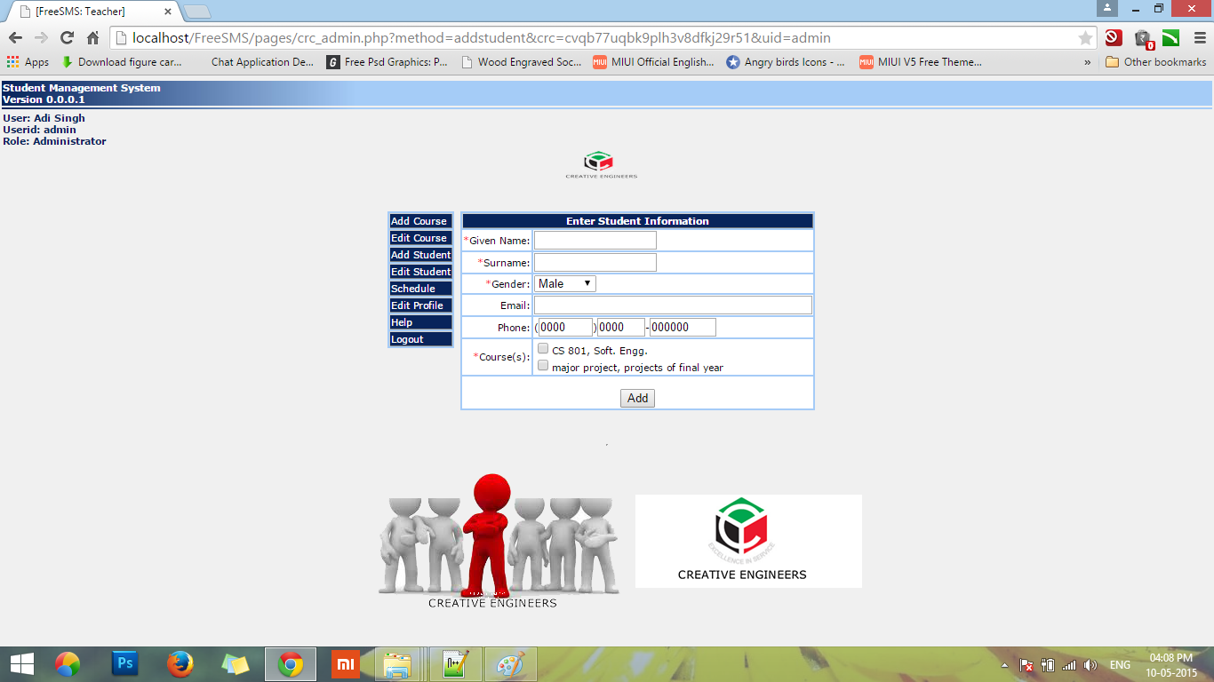
From this panel admin can add any New student
Admin Should know all the data of student and need to simply save the details
Student will automatically added into database

Teacher Panel
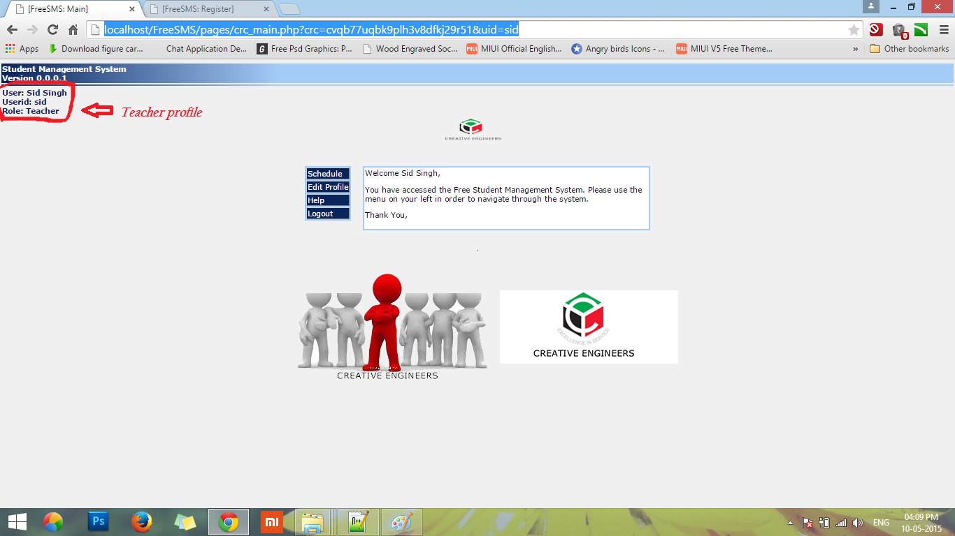

This is teachers Panel
Teachers can Do.
- Schedule Subject assign to him
- Edit his profile (common for all frofile)
- Help (Common for all)
- Logout (Common for all)

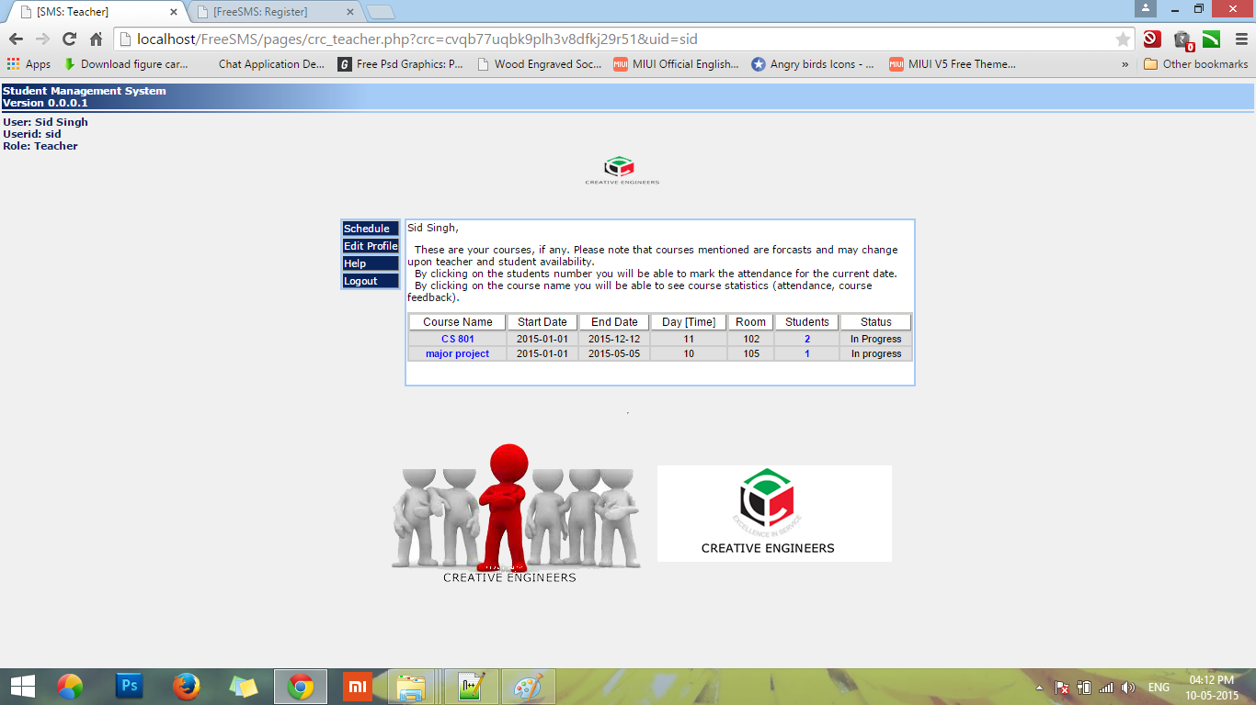

This is Schedule Panel for Teacher
Here Teacher will see what subject is assign to him and how many students are enroll in that subject and Start and End date of course
As well as where will be class held

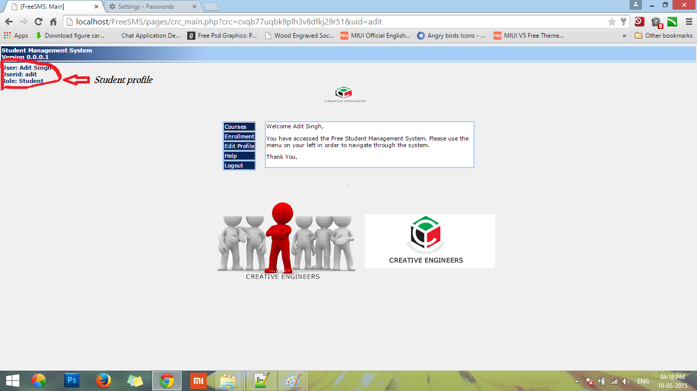
This is student panel
- Student can see which course is currently open for enroll or in session
- Student need to enroll himself in course which are available
- Edit profile (common for all)
- help (common for all)
- Logout (common for all)

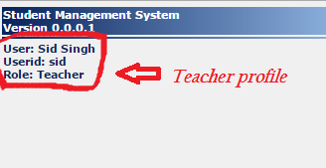

This corner is in Header.php shows role and username of Current Logged in profile

Chapter 4

IMPLEMENTATION & TESTING
________________________________________________

4.1. IMPLEMENTATION

The implementation view of software requirement presents the real world manifestation of processing functions and information structures. This computerized system is specified in a manner that dictates accommodation of certain implementation details.

The implementation environment of the developed system facilitates multiple users to use this system simultaneously. The user interfaces are designed keeping in mind that the users of this system are familiar to using GUI-based systems. Thus, we restricted ourselves to developing a GUI-based system so that it becomes easier for the end user to get acquainted to the developed system.

We have also followed the web based 4-tier architecture as the implementation architecture which is as follows:

The presentation tier or user services layer:
- This layer gives a user access to the application. It contains all the web pages so it is this interface through which user can access the application.
- This layer presents data to the user and optionally permits data manipulation and data entry.

The control tier or control layer:
- This layer gives a well separation between code and its connectivity with database.
- This layer includes the code (PHP code) and JS. Mainly this layer includes the replica of presentation layer pages and these pages are mainly control pages.

The business services layer:
- It consists of business and data rules. Also referred to as the business logic tier, the middle tier is where we as developers can solve mission-critical business problems and achieve major productivity advantages. The components that make up this layer can exist on a server machine, to assist in resource sharing. These components can be used to enforce business rules, such as business algorithms and data rules, which are designed to keep the data structures consistent within either specific or multiple databases. Because these middle-tier components are not tied to a specific client, they can be used by all applications and can be moved to different locations, as response time and other rules require.
- In our project we had created various classes appropriate to database and we implemented business logic here. According to request from presentation layer the appropriate rules called and it can access data through data tier.

The data tier or data services layer:
- This layer interacts with persistent data usually stored in a database or in permanent storage.
- In this layer we have implemented the basic function through data can be accessed like insert, update, delete, selection.
- Our Requirements are changing dynamically so we used four-tier architecture. The four-tier approach provides benefits such as reusability, flexibility, manageability, maintainability, and scalability.

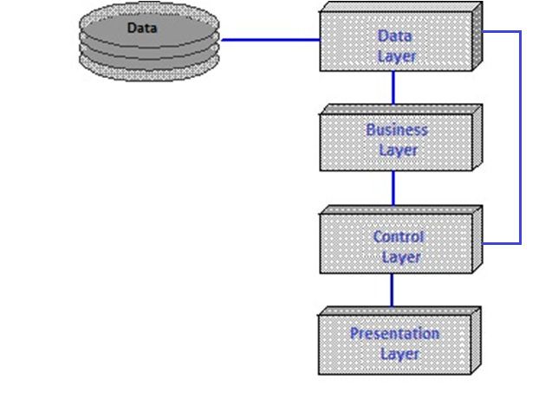

Fig 4.1 Four tier architecture

4.2 TESTING:
Software Testing has a dual function; it is used to identify the defects in program and it is used to help judge whether or not program is usable in practice. Thus software testing is used for validation and verification, which ensure that software conforms to its specification and meets need of the software customer.
Developer resorted Alpha testing, which usually comes in after the basic design of the program has been completed. The project scientist will look over the program and give suggestions and ideas to improve or correct the design. They also report and give ideas to get rid of around any major problems. There is bound to be a number of bugs after a program have been created.
Unit Testing
Module Testing
Sub-system Testing
System Testing
Acceptance Testing

Fig 4.1 Testing Step

Branch coverage
It is strategy in which test cases are designed to make each branch condition assume true & false values.

Conditional coverage
In this testing test cases are designed to make each component of composite conditional expression both true & false.

The Testing Process
We test the software process activities such as Design, Implementation, and Requirement Engineering. Because, design errors are very costly to repair once system has been started to operate, it is quite obvious to repair them at early stage of the system. So analysis is the most important process of any project.

Requirement Traceability
As most interested portion is whether the system is meeting its requirements or not, for that testing should be planned so that all requirements are individually tested. We checked the output of certain combination of inputs so that we can know whether it gives desirable results or not. Strictly sticking to your requirements specifications, give you the path to get desirable results from the system.

Testing Schedule
We have tested each procedure back-to-back so that errors and omissions can be found as early as possible. Once the system has been developed fully we tested it on other machines, which differs in configuration.

  - TESTING STRATEGY

There are types of testing that we implement. They are as follows:
- While deciding on the focus of testing activities, study project priorities. For example, for an on-line system, pay more attention to response time. Spend more time on the features used frequently.
- Decide on the effort required for testing based on the usage of the system. If the system is to be used by a large number of users, evaluate the impact on users due to a system failure before deciding on the effort.
- A necessary part of the test case is a definition of the expected result.
- Write test cases for invalid and unexpected as well as valid and expected input conditions.
- Thoroughly inspect the results of each test.
We have performed both Unit Testing and System Testing on WIMS to detect and fix errors. A brief description of both is given below.

Unit Testing

Objective
The objective of Unit Testing is to test a unit of code (program or set of programs) using the Unit Test Specifications, after coding is completed. Since the testing will depend on the completeness and correctness of test specifications, it is important to subject these to quality and verification reviews.

Input
- Unit Test Specifications
- Code to be tested

Testing Process
- Checking for availability of Code Walk-through reports which have documented the existence of and conformance to coding standards.
- Verify the Unit Test Specifications conform to the program specifications.
- Verify that all boundary and null data conditions are included.
- Integration Testing
After our individual modules were tested out we proceed to the integration testing to create a complete system. This integration process involves building the system and testing the resultant system for problems that arise from component interactions.
We have applied top-down strategy to validate high-level components of a system before design and implementations have been completed. Our development process started with high-level components and we worked down the component hierarchy.
- System Testing
System testing is actually a series of tests whose purpose is to fully exercise the computer-based system. It verifies that system elements have been properly integrated and perform allocated functions. It checks whether the system as a whole works as per requirement. We have used Performance testing. Performance testing - designed to test the run-time performance of software, especially real-time software.
- Performance Testing
This is designed to test the run-time performance of software within the context of an integrated system. Performance testing occurs throughout all steps in the testing process. Our system is checked for high load as well as low load.

Statistical Testing

Statistical Testing is used to test the program’s performance and reliability and to check how it works under operational conditions. Tests are designed to reflect the actual user inputs and their frequency.

The stages involved in the static analysis for this system are follows.
Control flow analysis
- Unreachable code
- Unconditional branches into loops

Data use analysis
- Variable used before initialization
- Variables declared but never used
- Variables assigned twice but never used between assignments
- Possible array bound violations
- Declared variables

Interface analysis
- Parameter type mismatches
- Parameter number mismatches
- Non-usage of the results of functions
- Uncalled functions and procedures

Storage management faults
- Images not Stored in Resources
- Out of Bound ->Program’s non-volatile memory.

  - TEST CASES

A test case is a set of conditions or variables and inputs that are developed for a particular goal or objective to be achieved on a certain application to judge its capabilities or features.
It might take more than one test case to determine the true functionality of the application being tested. Every requirement or objective to be achieved needs at least one test case. Some software development methodologies like Rational Unified Process (RUP) recommend creating at least two test cases for each requirement or objective; one for performing testing through positive perspective and the other through negative perspective.

- Test Case Structure
A formal written test case comprises of three parts -
Information
Information consists of general information about the test case. Information incorporates Identifier, test case creator, test case version, name of the test case, purpose or brief description and test case dependencies.
Activity
Activity consists of the actual test case activities. Activity contains information about the test case environment, activities to be done at test case initialization, activities to be done after test case is performed, and step by step actions to be done while testing and the input data that is to be supplied for testing.
Results
Results are outcomes of a performed test case. Results data consist of information about expected results and the actual results.

- Designing Test Cases
Test cases should be designed and written by someone who understands the function or technology being tested. A test case should include the following information -
- Purpose of the test
- Software requirements and Hardware requirements (if any)
- Specific setup or configuration requirements
- Description on how to perform the test(s)
- Expected results or success criteria for the test
Designing test cases can be time consuming in a testing schedule, but they are worth giving time because they can really avoid unnecessary retesting or debugging or at least lower it. Organizations can take the test cases approach in their own context and according to their own perspectives. Some follow a general step way approach while others may opt for a more detailed and complex approach. It is very important for you to decide between the two extremes and judge on what would work the best for you. Designing proper test cases is very vital for your software testing plans as a lot of bugs, ambiguities, inconsistencies and slip ups can be recovered in time as also it helps in saving your time on continuous debugging and re-testing test cases.

Chapter 5

RESULT
________________________________________________
5.1. PROJECT OUTCOMES
Results are outcomes of a performed test case. Results data consist of information about expected results and the actual results.
- The Internet password security
- Each applicant is given a login account through which he can view his own information and also modify and save it. He has the rights to access only his own information.
- The administrator has rights through which he can access and manage whole system.
- The password is encrypted before it is sent over the network. This increases the security level.
- MYSQL Server provides greater security to the database.

Chapter 6

FUTURE ENHANCEMENT AND CONCLUSION
________________________________________________
6.1. FUTURE ENHANCEMENT
The SMS has been developed with a main aim of making work easier and timesaving for the human capital. The whole system is bi-lingual at present and can be extended to other languages too with minor changes (not in coded).

The coding pattern is kept as dynamic as possible with minimum amount of static values to make it easier for future extensions. As the current system is expected to add more functionality and dependency according to requirement changes and technology, proper coding standards and working platform have been kept in mind to produce a quality product.

One enhancement is that we can make this application in more than 1 language as well. Adding attendance management is also one option for enhancement.

6.2. CONCLUSION
- SMS will be helpful to perform paperless work and manage all data.
- This provides easy, accurate, unambiguous and faster data access.
- Lesser learning curve - Consistent user interface, customized for the group of users, statistical information in various graphical and tabular forms.

Chapter 7

REFRENCES &BIBLIOGRAPHY ________________________________________________

REFERENCES

Web Sites

- www.tcs.com
-TCS official website
- http://sourceforge.net/
- Largest repository of open source code and applications available on the internet
- http://www.gnu.org
- Web site of the Free Software Foundation (FSF) which supports the open source community
- http://www.thefreecountry.com
- Large collection of good programming resources
- http://www.1001tutorials.com/
- Large collection of good tutorials for reference
- http://www.codeguru.com/
- Good articles on programming.
- Books

- Asp.net Professional 1.1 (Wrox Publication)
By: Wrox Publication
- JavaScript In 21 Days
- JavaScript Bible
By: Danny Goodman
- Mastering SQL Server 2000
- Software Engineering – A Practitioner’s Approach
By: Roger S. Pressman
- Software Engineering
By: Ian Somerville
- VB.net Professional (Wrox Publication)
By: Wrox Publication

